2023 - 2024
Computer vision challenge
Autonomous driving project
Group 6: Katoo, Ege, Francesco

Inhoud
1. Introduction 4
2. Data capture and logging 5
2.1. Data collection 6
3. Model 7
3.1. Data augmentation and balancing 8
3.1.1. Data Multiplication 8
3.1.2. Random Crop and Resize 8
3.1.3. Challenges with Augmentation 8
3.2. Model architectures explored 8
3.2.1. Initial Models: ResNet-18 and ResNet-34 8
3.2.1.1. Non-Pretrained ResNet-18 8
3.2.1.2. Pretrained ResNet-18 8
3.2.1.3. Non-Pretrained ResNet-34 8
3.2.1.4. Pretrained ResNet-34 9
3.2.2. Attempted Sequential Model: CNN-LSTM Hybrid 9
3.2.2.1. ResNet-34 + LSTM Hybrid 9
3.2.3. Dataset Restructuring and Folder-Based Organization 9
3.2.4. Advanced Models: ResNet-34 and ResNet-50 (Pretrained and Non-Pretrained) 9
3.2.4.1. Non-Pretrained ResNet-34 and ResNet-50 9
3.2.4.2. Pretrained ResNet-34 and ResNet-50 9
3.3. Training techniques and model optimization 10
3.3.1. Learning Rate Scheduling and One-Cycle Policy 10
3.3.2. Dropout Regularization 10
3.3.3. Mixed Precision Training 10
4. Capture and drive 11
4.1. Real-Time Autonomous Driving 12
4.1.1. Capture and Drive 12
4.1.2. Key Components: 12
4.1.2.1. Screen Capture 12
4.1.2.2. Frame Preprocessing 12
4.1.2.3. Prediction and Action 12
4.1.2.4. Challenges 12
5. Performance evaluation and analysis 12
5.1. Confusion Matrix Insights 12
5.2. Top Loss Frames 13
5.3. Gameplay Testing Observations 13
6. Limitation and future recommendations 13
6.1. Key Limitations Identified 13
6.1.1. Data imbalance and insufficiency in turn scenarios: 13
6.1.2. Overfitting to straight path data: 13
6.1.3. Limitations of model design: 13
6.1.4. High-confidence misclassifications: 14
6.2. Recommendations for Future Work 14
6.2.1. Focused Data Collection for Turns and Different Scenarios: 14
6.2.2. Exploring Vision Transformers (ViT): 14
6.2.3. Improving Temporal Modeling with Transformer-Based Layers: 14
6.2.4. Adding More Contextual Inputs: 14
6.2.5. Exploring Reinforcement Learning Approaches: 14
7. Use of Generative AI Tools 15
7.1. Helpful Suggestions for Model Optimization: 15
7.2. Support with Report Drafting and Organization: 15
7.3. Assistance in Debugging and Code Optimization: 15
7.4. Speeding Up Workflow: 15
8. Conclusion 16

Introduction
This project aimed to develop a deep learning-based autonomous driving model for the game Trackmania. The goal was to create a model that could navigate a vehicle using directional commands (up, down, left, right) in real-time gameplay. While our models achieved high accuracy on validation datasets, they struggled to generalize to the actual game, especially during turns. These struggles highlighted the need for refined data and architecture adjustments, leading to multiple iterative attempts and advanced training techniques.

Data capture and logging
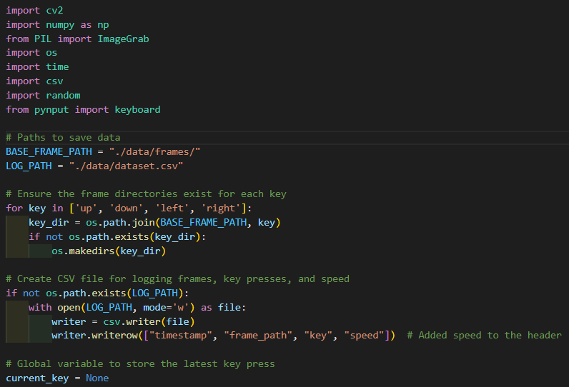
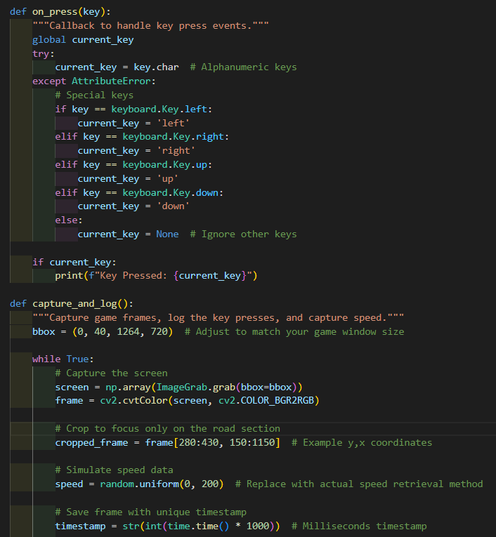
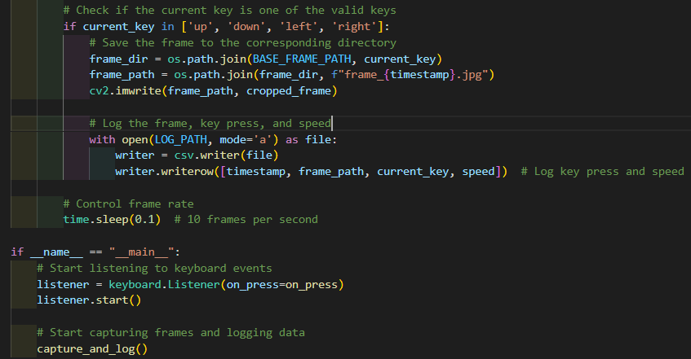

Data collection
Our data collection process was critical to the model’s performance. We developed a custom script that captured frames from the game along with corresponding directional inputs. The data included:
- Frame Capture: Using ImageGrab, frames were extracted from the game and down sampled to reduce computational demands. The frames focused on the road and discarded irrelevant background areas.
- Directional Key Logging: Key presses (up, down, left, and right) were recorded in sync with frame captures to simulate human driving actions.
- Turn Data Deficiency: The collected data had an inherent imbalance—straight paths outnumbered turns significantly, a pattern that would later reveal itself as a primary obstacle to model effectiveness.
Over several iterations, we expanded the dataset with targeted recordings to capture more turns. However, even after several rounds of data enrichment, turns remained underrepresented compared to straight paths, ultimately impacting the model’s real-world performance.

Model
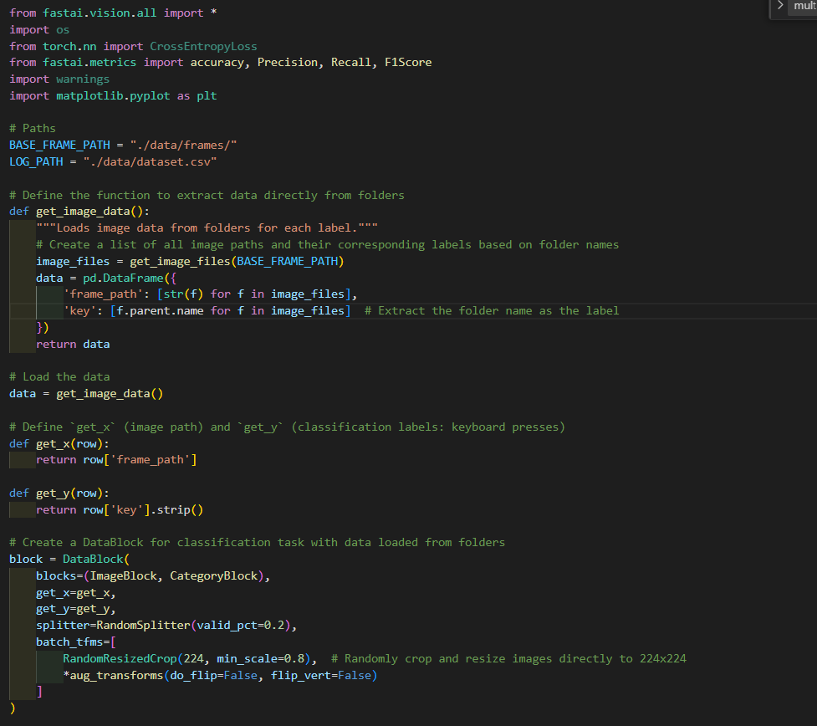
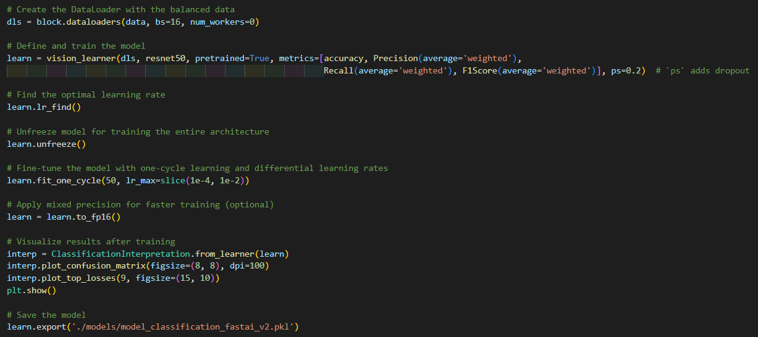

Data augmentation and balancing
Given the data imbalance, we employed various augmentation techniques to multiply the available data and improve the model's ability to generalize.

Data Multiplication
At some point we also used FastAI’s mult parameter within aug_transforms to effectively multiply the dataset without creating additional files on disk. This allowed us to artificially expand the dataset size, especially for underrepresented classes, without incurring additional storage demands.

Random Crop and Resize
We used RandomResizedCrop to simulate slight variations in perspective, mimicking different viewpoints of the same scene. This proved useful for generalization in straight-path scenarios but didn’t fully resolve the model’s deficiencies with turn data.

Challenges with Augmentation
Augmentation techniques like cropping and resizing introduced some diversity, but they couldn’t fully address the lack of true turn data. Furthermore, augmentations like default flipping or rotating were avoided, as they would produce unrealistic perspectives. Flipping or rotating could mislabel directions, making a left turn look like a right, or up look like down, which would confuse the model.

Model architectures explored
Our approach involved testing several architectures, beginning with simpler models before progressing to more advanced configurations. The experiments followed a specific order, reflecting our evolving understanding of the model’s needs. We’ve trained each of the models with 30-50 epochs every time.

Initial Models: ResNet-18 and ResNet-34

Non-Pretrained ResNet-18
This was our first model, providing a baseline for performance. Training the non-pretrained ResNet-18 model resulted in an accuracy of around 65-70%. This model struggled with both straight and turn scenarios, which confirmed the necessity of pretraining and a more complex model for effective feature extraction.

Pretrained ResNet-18
To improve the model's generalization, we introduced pretraining. The pretrained ResNet-18 reached approximately 70% accuracy and showed minor improvements in handling straight paths. However, it still failed to interpret turn data reliably, often defaulting to predicting “up” (straight) with high confidence even on turns. Observing its shortcomings, we decided to try a larger model.

Non-Pretrained ResNet-34
Next, we tested ResNet-34 without pretraining. This model reached around 70% accuracy, showing slightly better performance on straight paths but exhibited severe overfitting. Without the benefit of pretraining, the ResNet-34 struggled to generalize and performed poorly on turns, consistently defaulting to straight-path predictions.

Pretrained ResNet-34
Pretraining the ResNet-34 model improved validation accuracy to around 80%. This was our first model to achieve such high accuracy; however, this did not translate to real-world gameplay performance. During gameplay, the model continued to misclassify turns with high confidence, a recurring issue that suggested the data was insufficiently balanced or varied.

Attempted Sequential Model: CNN-LSTM Hybrid
Recognizing that static CNNs might lack the temporal understanding necessary for turns, we attempted to add a sequential component using an LSTM.

ResNet-34 + LSTM Hybrid
This hybrid model used ResNet-34 for feature extraction and an LSTM layer to incorporate temporal dependencies. The model reached around 80% accuracy, slightly improving turn predictions compared to the ResNet-34 alone. However, it remained far from reliable in gameplay due to:
- Data Insufficiency: The sequential model also suffered from limited turn data, which hindered its ability to interpret turn sequences.
- Computational Cost: This configuration was computationally intensive, significantly increasing training time without proportional gameplay improvement.
Despite these challenges, the CNN-LSTM approach highlighted the potential of temporal modeling for such tasks, suggesting that with richer temporal data, it could perform better.

Dataset Restructuring and Folder-Based Organization
Upon the advice we’ve received and to streamline the data input process and further refine the dataset, we reorganized the data into separate folders for each action (up, down, left, right). This allowed us to simplify the data loading pipeline in FastAI and facilitated better control over data distribution. After restructuring, we retrained models on this dataset.

Advanced Models: ResNet-34 and ResNet-50 (Pretrained and Non-Pretrained)
Following the dataset restructuring, we revisited pretrained and non-pretrained ResNet models, using both ResNet-34 and the deeper ResNet-50.

Non-Pretrained ResNet-34 and ResNet-50
Both non-pretrained ResNet-34 and ResNet-50 achieved moderate accuracy scores of around 85%. However, without pretraining, these models overfit on straight paths, providing limited improvement over the previous iterations.

Pretrained ResNet-34 and ResNet-50
Pretrained versions of ResNet-34 and ResNet-50 achieved approximately 95% validation accuracy, particularly excelling on straight-path predictions. However, despite high accuracy, these models continued to perform poorly on turns in actual gameplay. This led to frequent misclassifications where turns were predicted as straight paths. Observing the limitations of even the deeper ResNet-50, it became clear that the primary issue lay with the data rather than model capacity.
Model Version | Architecture | Validation Accuracy | Real-World Turn Performance
ResNet-18 (Non-Pretrained) | Lightweight CNN | ~70% | Poor turn accuracy
ResNet-18 (Pretrained) | CNN with Pretraining | ~70% | Slightly better on straight paths
ResNet-34 (Non-Pretrained) | Medium-sized CNN | ~85% | Overfit to straight paths
ResNet-34 (Pretrained) | Medium CNN with Pretraining | ~95% | High validation accuracy, poor in turns
ResNet-50 (Pretrained) | Deeper CNN with Pretraining | ~95% | Limited improvement on turns
ResNet-34 + LSTM | CNN-LSTM Hybrid for Temporal Data | ~85% | Minor improvement, computationally costly

YOLO-Based Object Detection for Trackmania
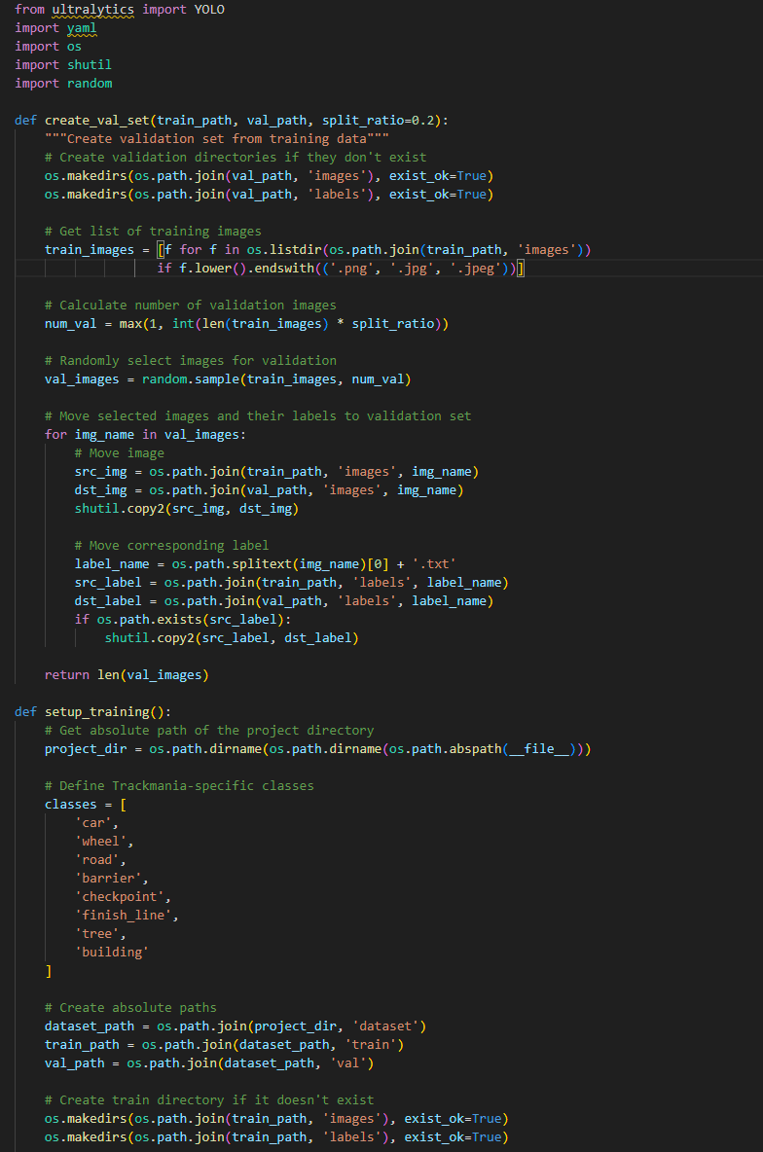
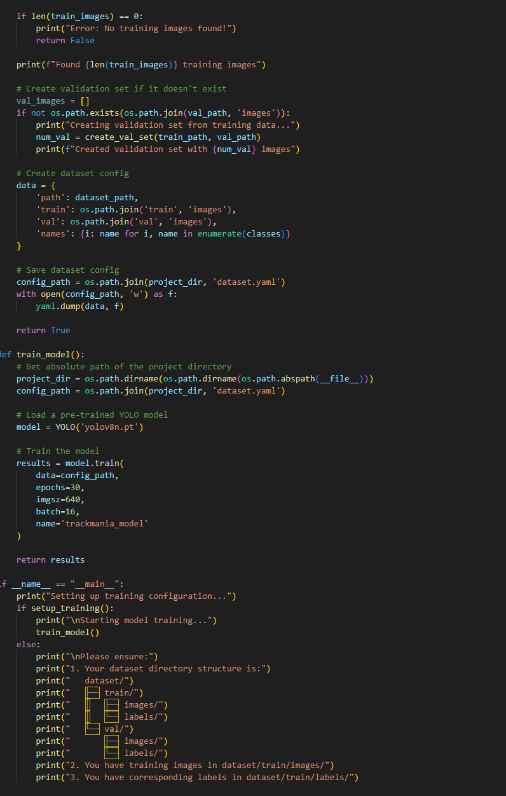

Overview of YOLO Architecture
Briefly introduce YOLO as an efficient, single-pass object detection model, which is capable of identifying multiple objects in real-time applications like Trackmania. The YOLO model processes each image in one go, predicting bounding boxes and classifying objects (e.g., "car," "road," "checkpoint") with corresponding confidence scores.

Implementation and Labeling Process

Code Workflow:
The detection pipeline, implemented in detect.js, processes screenshots by resizing them to 640x640 pixels, converting them into tensors, and passing them through the YOLO model for object prediction. Detections are filtered by confidence level to retain high-quality predictions. The code is configured to evaluate static screenshots rather than real-time gameplay, iterating through images in a designated "screenshots" directory.

Labeling and Data Limitations:
Initial trials with YOLO’s automated labeling proved insufficient, as the limited training data resulted in incorrect classifications. To address this, manual labeling was performed on a select subset (approximately 40 images) to refine detection quality. However, this dataset remains relatively small, and expanding labeled data across a wider range of scenarios is essential for robust detection accuracy.

Training techniques and model optimization

Learning Rate Scheduling and One-Cycle Policy
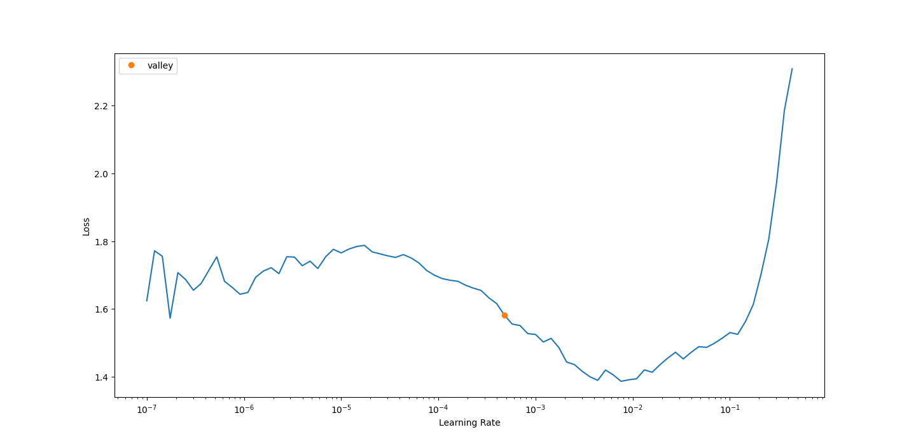
Using FastAI’s learning rate finder, we identified optimal learning rates for each model iteration. The one-cycle learning rate policy proved effective in achieving faster convergence, especially on deeper architectures. While this technique enabled faster training, it didn’t solve the underlying problem of turn prediction.

Dropout Regularization
We applied dropout with a probability of 0.2 to improve generalization, particularly in pretrained models. Dropout helped reduce overfitting on straight paths but had minimal impact on turn accuracy.

Mixed Precision Training
Using mixed precision training allowed us to speed up computations and reduce memory usage, which was especially beneficial for ResNet-50. This technique was instrumental in enabling larger models within our limited resources.

YOLO-Specific Data Requirements
In train.js, the model is built and trained on the manually labeled dataset. Due to the limited sample size, the model's detection accuracy is constrained, highlighting the need for a more extensive, well-annotated dataset to improve YOLO’s ability to generalize effectively across various game elements.

Capture and drive
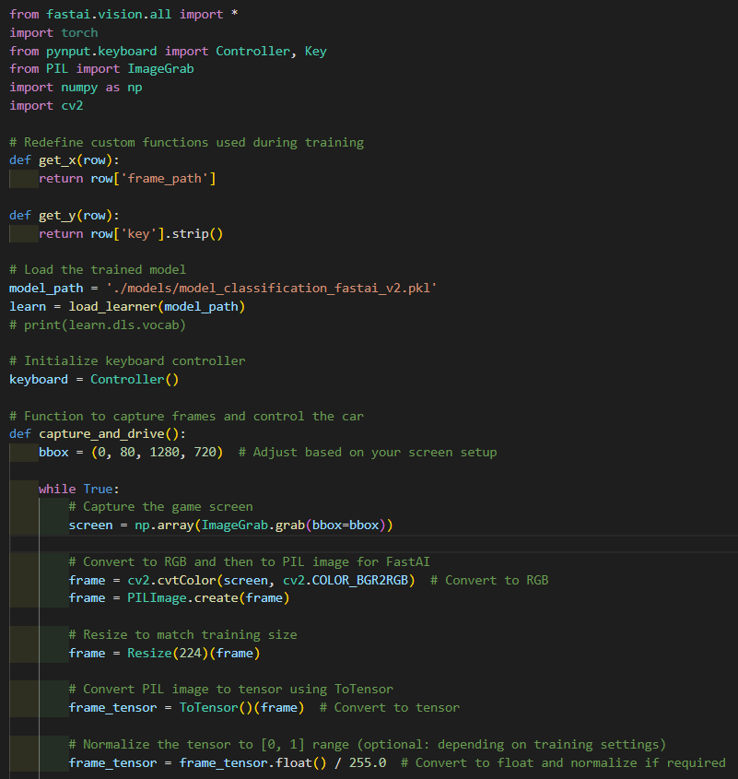
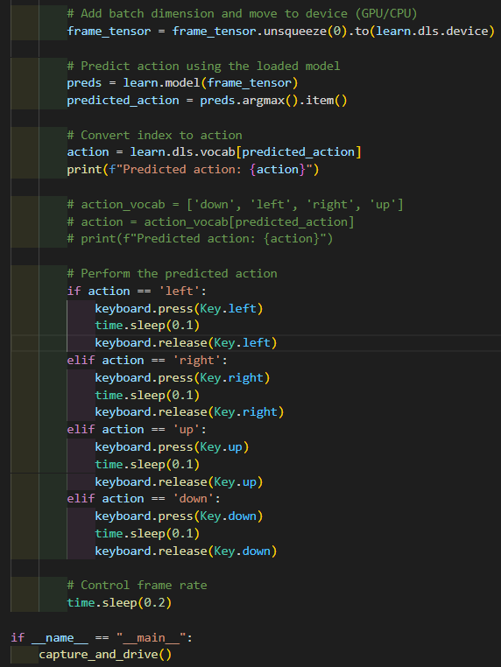

Real-Time Autonomous Driving

Capture and Drive
The Capture and Drive section is the final step of the project, where the trained model is deployed to control the car in real-time. This script captures the game screen, processes the frames, and feeds them into the trained model to predict the next action. Based on the model's predictions (up, down, left, or right), the script uses simulated keyboard commands to drive the car autonomously within the game environment.

Key Components:

Screen Capture
Using the ImageGrab library, the script continuously captures the game screen, converting each frame to a format compatible with the model.

Frame Preprocessing
Each frame is resized and normalized to match the training configuration, ensuring consistent input for accurate predictions.

Prediction and Action
The processed frame is passed through the model to predict the next action. The script then maps the prediction to a keyboard command, which is executed using the pynput library to control the car's movement in real-time.

Challenges
While high accuracy was achieved during training, real-time performance presented challenges. Correctly predicting turn commands (especially left and right) remained difficult, possibly due to rapid scene changes in game environments, which the model struggled to interpret. Further tuning, such as adjusting frame capture rates or incorporating more specific turn data, could help enhance real-time prediction accuracy. This section demonstrates the culmination of data collection, model training, and deployment, providing a comprehensive test of the model's real-world applicability in a dynamic gaming environment.

Performance evaluation and analysis

Confusion Matrix Insights
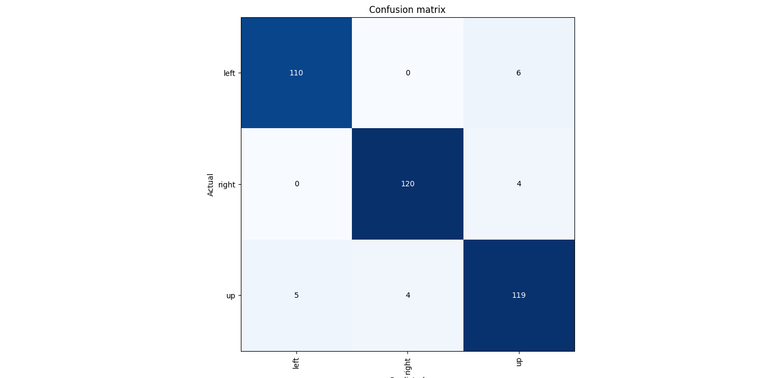
Each model's confusion matrix revealed extensive misclassifications in turn scenarios:
- Left vs. Right Confusion: Models frequently confused left and right turns with straight paths, with the confusion matrix skewing heavily toward the “up” class.
- Consistent Missed Turn Predictions: Models often defaulted to "up" predictions in turn situations, highlighting the data imbalance issue.

Top Loss Frames
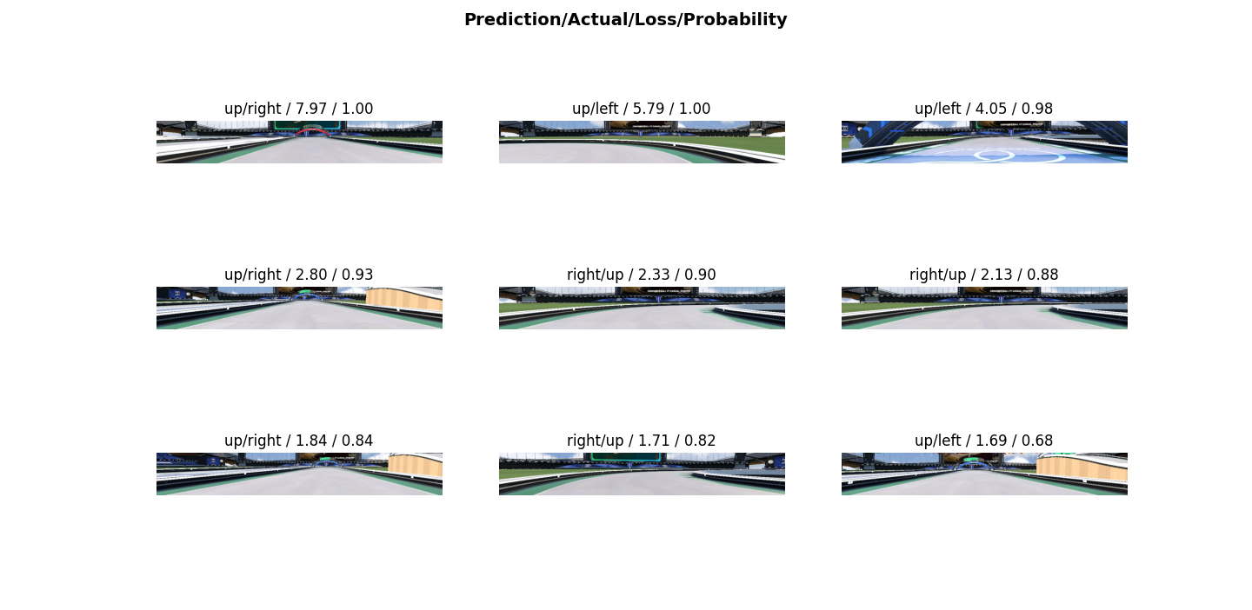
Top-loss frames consistently included turns, showing the model’s difficulty in predicting these scenarios. These frames had high associated loss values, indicating the model’s lack of confidence in turn situations.

Gameplay Testing Observations
While validation accuracy was high, real-world gameplay testing exposed the model’s core limitations:
- Frequent Off-Track Events: The car frequently went off-track during turns due to mispredictions.
- Inconsistent and Erratic Behavior: The model often made unpredictable decisions when encountering rapid turns, underscoring the need for a better temporal understanding.

YOLO Model Performance
Detection on Pre-Captured Screenshots: YOLO’s current application is limited to static images rather than live gameplay, as detection is applied only to pre-captured screenshots. This constraint reflects the need for additional labeled data and further optimization to support accurate, real-time detection.
Impact of Dataset Limitations: The small manually labeled sample (around 40 images) restricts YOLO’s accuracy, resulting in occasional misclassifications and missed detections. To achieve higher precision and reliability, expanding the labeled dataset is crucial.
For YOLO to reach its full potential in Trackmania, a comprehensive and diverse labeled dataset is essential. While manual labeling improved initial results, a broader dataset is needed to enhance accuracy and enable reliable real-time detection. Expanding labeled data would not only improve performance on static images but also support advanced autonomous driving applications in dynamic gaming environments.

Limitation and future recommendations

6.1. Key Limitations Identified
Throughout our trials, several critical limitations surfaced, influencing both model accuracy and real-world applicability:

Data imbalance and insufficiency in turn scenarios:
- Despite multiple efforts to expand our data, our dataset remained heavily skewed towards straight paths. Even after reorganizing and balancing the data, the turn-specific data remained insufficient to train the model effectively for consistent real-world application.
- Because there were so many straight-path frames, the model mostly learned to predict straight paths, making it assume going straight was the default. This imbalance caused problems when the model needed to predict turns, especially in situations with several turns in a row.

Overfitting to straight path data:
- Due to the overweight of straight-path data in the training set, models like ResNet-34 and ResNet-50 tended to overfit on straight paths. This showed up as high accuracy in testing, but poor performance with turns. The model often confidently predicted “straight” when it should have recognized a turn.
- This preference for straight paths showed up in gameplay, where the model repeatedly failed to adjust to curves, even after we tried different versions of the model.

Limitations of model design:
- Although we experimented with a CNN-LSTM hybrid to capture temporal patterns, this didn’t help much. The data wasn’t varied enough to help the model understand turns and transitions well.
- While this approach showed potential, it also suggested we might need to explore more advanced models, like Vision Transformers. But we couldn’t fully explore these options due to limits on resources and data

High-confidence misclassifications:
- A common issue was that the model often made very confident errors, especially on turns. In real-life gameplay, this meant incorrect, high-confidence predictions, making the model unreliable for actual driving. These high-confidence errors showed that good validation scores didn’t match the model’s real-world performance.

Recommendations for Future Work
Based on our findings and observations, we identified several potential areas for improvement:

Focused Data Collection for Turns and Different Scenarios:
Future efforts should collect a balanced amount of data for different types of turns, such as gradual curves, sharp turns, and U-turns. This can be done by setting up dedicated data collection sessions focused only on turns, capturing a variety of angles, speeds, and perspectives to give the model a deeper understanding of turn behavior.
By devoting a substantial part of the dataset to turn-specific scenarios, future models can avoid the current bias towards straight paths and perform better in real-world situations.

Exploring Vision Transformers (ViT):
Given the challenges with traditional CNNs and CNN-LSTM models, Vision Transformers could be a promising alternative. Transformers excel at capturing complex spatial relationships and understanding context across an image, which may help the model interpret turns more effectively.
Although Transformers need more computing power, they might provide better spatial and temporal insights, making them a potentially effective option for overcoming the limitations seen with CNN models.

Improving Temporal Modeling with Transformer-Based Layers:
If there are enough resources, adding Transformer-based temporal layers, like Vision Transformers with attention mechanisms, could improve the model’s ability to recognize turns. This setup would help capture patterns over time, enhancing the model’s handling of sharp turns and quick directional changes.
Transformers’ capability to track long-term dependencies could address some of the unstable behavior seen in turns, making the model more reliable in real-life scenarios.

Adding More Contextual Inputs:
To make the model more robust, future versions could use extra data like speed, steering angle, or distance to road edges. These inputs could help the model distinguish between straight paths and turns more easily and improve decision-making in challenging scenarios. By using multiple types of data, the model could gain a fuller picture of the environment.

Exploring Reinforcement Learning Approaches:
Another future direction is to look into reinforcement learning (RL) methods to help the model make better decisions in real time. Techniques like DQN or PPO could provide feedback based on the model’s actual in-game performance, helping it learn optimal driving strategies through trial and error. This could improve turn prediction and make the model more adaptive, especially when combined with supervised learning approaches

Use of Generative AI Tools
Throughout the project, we leveraged AI-driven tools, particularly ChatGPT, for guidance, ideation, and troubleshooting. Generative AI tools played a key role in:

Helpful Suggestions for Model Optimization:
- ChatGPT provided valuable guidance on tuning parameters, trying new model structures, and handling data imbalances. This support helped us make more informed choices about our model’s setup, saving time we would have spent on manual testing.

Support with Report Drafting and Organization:
- The AI tool helped draft and organize parts of this report, making technical explanations clearer and easier to understand. ChatGPT helped create a well-organized narrative, allowing us to share complex ideas and results more effectively.

Assistance in Debugging and Code Optimization:
- ChatGPT provided quick solutions to code issues and suggested ways to improve training speed and efficiency. By using ChatGPT for debugging, we resolved several challenges during data preprocessing, augmentation, and model training.

Speeding Up Workflow:
- Generative AI tools helped us make model improvements faster by providing real-time suggestions. While we reviewed each suggestion carefully, these tools significantly streamlined our workflow, helping us meet project goals on time.

Conclusion
This project provided valuable insights into the challenges of applying deep learning models to autonomous driving tasks within a dynamic, fast-paced gaming environment. While our models achieved high accuracy on validation data—up to 95% in some cases—they struggled with real-world performance due to the lack of balanced turn data and model limitations. Despite multiple attempts with different architectures and training techniques, the models consistently misclassified turns with high confidence, making them unreliable in practical gameplay scenarios.
Key takeaways from this project include:
- The Importance of Balanced Data: Turn data is critical for any model that aims to navigate complex paths effectively. Without sufficient diversity in the dataset, high validation accuracy may not translate to reliable real-world performance.
- Limitations of CNN-Based Architectures for Dynamic Driving: Static CNNs like ResNet, even with LSTM layers, lack the temporal and spatial complexity to handle dynamic environments with frequent directional changes. Future work would benefit from exploring alternative architectures, such as Vision Transformers, that are better suited for these challenges.
- Potential for Temporal and Contextual Enhancements: By incorporating additional contextual inputs and exploring sequential models with greater temporal awareness, future models could improve their understanding of the driving environment, leading to more accurate predictions in real-time gameplay.
Ultimately, while the project faced challenges in achieving reliable turn predictions, it provided a strong foundation for further exploration. Future work can build on these findings to develop a more advanced, contextually aware autonomous driving model that leverages deeper temporal dependencies and a richer dataset.

Follow us
www.thomasmore.be
fb.com/ThomasMoreBE
#WeAreMore

